You are given an n x n binary grid board. In each move, you can swap any two rows with each other, or any two columns with each other.

Return *the minimum number of moves to transform the board into a* ***chessboard board***. If the task is impossible, return -1.

A **chessboard board** is a board where no 0's and no 1's are 4-directionally adjacent.

**Example 1:**

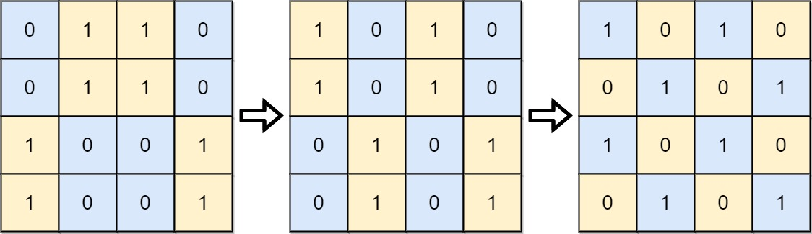

Input: board = [[0,1,1,0],[0,1,1,0],[1,0,0,1],[1,0,0,1]]  
Output: 2  
Explanation: One potential sequence of moves is shown.  
The first move swaps the first and second column.  
The second move swaps the second and third row.

**Example 2:**

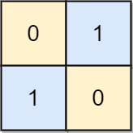

Input: board = [[0,1],[1,0]]  
Output: 0  
Explanation: Also note that the board with 0 in the top left corner, is also a valid chessboard.

**Example 3:**

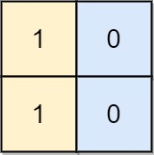

Input: board = [[1,0],[1,0]]  
Output: -1  
Explanation: No matter what sequence of moves you make, you cannot end with a valid chessboard.

**Constraints:**

* n == board.length
* n == board[i].length
* 2 <= n <= 30
* board[i][j] is either 0 or 1.